Lovely Professional University
School of Computer Application
Punjab



Software Requirements Specification

Title: IoT & Deep Learning Enabled Smart Body Heater
Course Code : CAP750
Section : D2445

Submitted By: Submitted to:
Debjyoti Dutta(12418049) Dr. Pallvi
Anuvab Mazumder(12417110) Aabid Mushtaq Najar
Kushvinder Singh(12411069) Dr. Navpreet Kaur
Ayush Ghai(12405625)

Index

Project Overview 3

Purpose and Scope 3
- Project Scope

Product/Service Description 4
- User Characteristics 4
- Assumptions 4
- Constraints 4
- Dependencies 4

Requirements 5
- Functional Requirements/Non-functional Requirements 5
- Usability 6
- Performance 6
- Capacity 6
- Availability 6
- Latency 6
- Manageability/Maintainability 6
- Monitoring 7

System Interface/Integration 7
- Overall System Architecture of the Smart Body Heater 7
- ER Diagram 8
- Data Flow Diagram 8
- Use case Diagram 9
- Software Requirements 10
- Hardware Requirements 10
- Security 10
- Protection 10

Executive Summary

Project Overview
Maintaining the safe and comfortable body temperature level is very important for the elderly, arthritis patients, and cold-sensitive people. Traditional heating systems lack, among others, personalization, continuous monitoring and automatic safety.The IoT-Enabled Smart Body Heater System is a wearable healthcare solution to monitor physiological parameters and predict thermal needs based on the deep learning approach and to automatically control the heating intensity. A cloud-powered back-end and web dashboard allows for the monitoring of vitals in real-time, the enforcement of safety measures and even the supervision of caregivers.

Purpose and Scope
The purpose of this project is to anticipate the potential risks, related to body temperature imbalance and to design, organize and control the operation of systems, so that safe and adaptive thermal comfort is achieved.
Due to lack of certainty in environmental and physiological condition thermal requirements can not always be anticipated accurately. Therefore, the data is continuously monitored by the system and intelligent control is applied to ensure the safety of user data.
The system makes use of the following activities:
- planning - establishing system goals and safety limits;
- organizing - integration of hardware, software and cloud services;
- staffing - assigning roles (development and maintenance);
- directing - managing system behavior with the help of AI models;
- monitoring - monitoring temperature, pulse, and system status;
- controlling - controlling the intensity of the heater and safety shutdowns;
- innovation - applying deep learning in predictive control; representing - providing interfaces for users & caregivers.

Project Scope:
This project scope refers to the key activities that are associated with design, development, implementation, and evaluation of IoT-Enabled Smart Body Heater System, including hardware integration, software development, artificial intelligence modeling, and system validation to assure safety, performance, and reliability.
- Estimation activities: Thermal estimate and heater intensity estimation using Artificial Intelligence Models.
- Scheduling: Scheduling of collecting sensor data and heater response intervals timing.
- Resource allocation: Allocation of computing resources, power resource and network resources as well, to be done in a proper manner.
- Quality management: Maintaining accurate sensors and precise predictions.
- Risk management: How to prevent overheating, burns, and hypothermia. Change control: Enabling firmware and software updates.
- Decision-making management: Automating heat control-related decision-making with deep learning.
- Gathering information: Collecting requirements relating to healthcare safety and comfort.
- Project acceptance criteria: Checking the desired goals of the project for safety, performance, and usability requirements.
- Project execution procedure: Hardware, back-end and AI models implementation.
- Work Breakdown Structure: Breaking down work into hardware, software, AI and testing modules
- Controlling various processes: Monitoring development and system performance
- Validation of various processes: Testing the functionality, safety limits and reliability.

Product/Service Description
The product provides a wearable heating service that measures health data, predicts future thermal demands and automatically adjusts heater intensity in a systematic and safe way. The system has continuous operation and remote monitoring from a web dashboard.

User Characteristics
General profiles of users that will interact with the system include:
- Elderly and Arthritis user: Primary users that require constant warmth and safety.
- Cold sensitive users: User who suffers from discomfort in low temperatures.
- Caregivers and healthcare staff: Users that monitor health data and receive an alert.
- System administrators: These are users responsible for maintenance and updates.

Assumptions
- The system will be used by people that need thermal assistance.
- It is a device that is wearable and needs a stable internet connection.
- Users will access the dashboard using either a computer or a mobile browser.

Constraints
There are several design factors which limit design options:
- The system requires continuous Wi-Fi connectivity in order to process in the clouds.
- Hardware and software components may contain security vulnerabilities.
- Improper usage may have an indirect effect on user satisfaction. System Resources: system limited by battery capacity ESP32 Hardware
- The web dashboard in particular must support modern browsers that are compatible with the HTML 5 standard.

Dependencies
Registered user accounts are needed in order to access the dashboard. In order to make correct predictions, accurate calibration of sensors is needed. Heating control is based on cloud and AI availability.

Requirements
System and Functional Specifications
- The system has to have ESP32 based wearable module with sensors.
- Sensor data ought to be true and it should be updated on a regular basis.
- User health data should be recorded and stored securely.
- Heating decisions need to be automatic and from AI.
- MLL Caregivers need to access the reports on the dashboard.

Functional Requirements:
Sl no | REQUIREMENT | COMMENTS | PRIORITY
1 | User Registration | Enable the users to sign up, have individual profiles to provide personalized monitoring and control. | High
2 | Sensor Data Acquisition | Continuously gather information on body temperature, pulse rate with the sensor using IoT. | High
3 | Data Transmission | The ESP32 module shall be responsible for securely sending the data of the sensors to the backend server | High
4 | DL Prediction | It involves in the use of deep learning models to predict the future body temperature and cold-risk situations. | High
5 | Heat Control | Automatically adjust the heater depending on the output of AI prediction models. | High
6 | Safety Shutdown | Automatically turn off the heating element on detection of heating element over abnormal conditions. | High
7 | Dashboard Visualization | Display real-time data from sensors, graphs and status of the system by a web-based dashboard. | High
8 | Alerts and Notifications | Create alert and notifications for risk conditions such as overheating or hypothermia. | Medium
9 | Data Storage | Able to securely record the historical sensor data and user information for future reference. | Medium

Usability
Without any technical knowledge, the easy wearing and operating of the smart body heater is also easily performed by the user. Caregiver can check user health status using web dashboard. The dashboard interface is simple and easy to grasp to every type of users.

Performance
Sensor and health data can be accessed from any remote location. Multiple users and caregivers can use the system and access it together. Data processing, alerts and heater control operations are processed in real time.

Capacity
The back-end server can also serve several wearable devices simultaneously. The system enables access to health data and reports, both historic. Automated control minimizes the need for manual intervention. The user interface allows a quick and efficient interaction.

Availability
- The system shall be available 24X7 for monitoring and control.
- Health data and reports shall be represented graphically on the dashboard.
- In case of system failure, there is a possibility to recover data from the backup server.
- The system takes care of continuous monitoring without interruptions.

Latency
Any issues related to the system shall be fixed within an acceptable period of time and heater reaction to AI decisions shall be immediate, within one second.

Maintenance:
The work of maintenance is to provide continuous, safe, and reliable operation of IoT-Enabled Smart Body Heater System. As the system is composed of wearable hardware hard-ware, cloud software and AI components, periodical maintenance is required to ensure the absence of faults and normal functioning of the system.
The system shall support the firmware updates and back-end software updates as well as AI model improvements without impacting the core functionality. Maintenance activities also consist sensor calibration, performance optimization and security patching activities.
The following are the maintenance requirements:
- User credentials shall be safely stored using encryption.
- The system shall be capable of software and firmware updates when needed.
- In case of system failure, recovery should be done within one hour.
- System errors that are logged shall be reviewed for the purpose of enhancing the reliability.

Monitoring
Monitoring provides proper functioning of the system and early in detecting failures. The system constantly checks sensor readings, heating behavior and communication situation. If any abnormal behavior such as overheating, sensor failure or communication loss is detected, corrective actions shall be taken automatically.
- Sensor data shall be monitored around anomalies.
- Operation of heaters, to avoid unsafe temperature levels, shall be monitored.
- System events and errors shall get logged.
- All data in the process of being monitored will be stored securely.

System Interface/Integration

Overall System Architecture of the Smart Body Heater
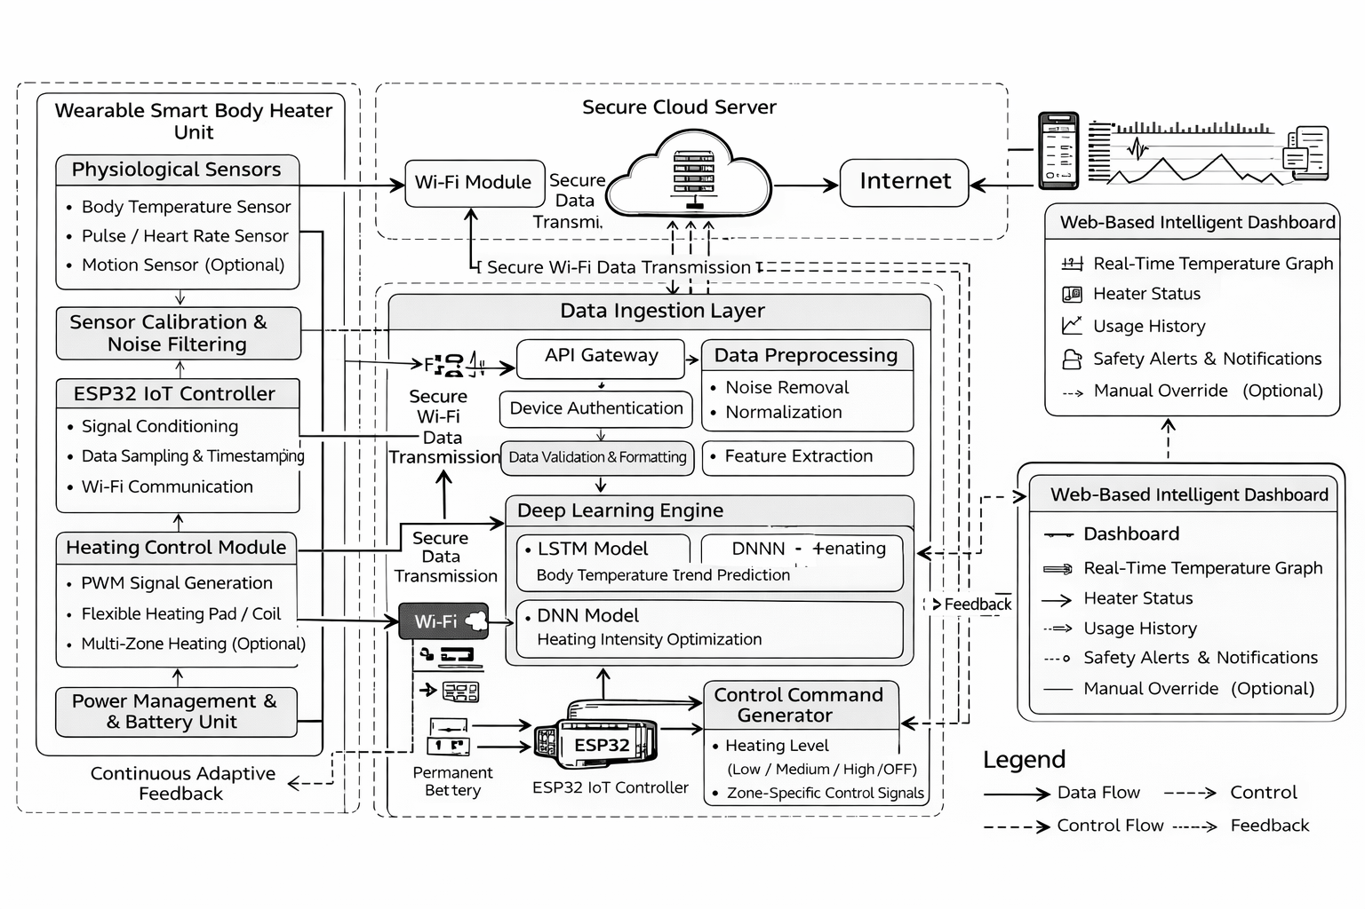

ER Diagram
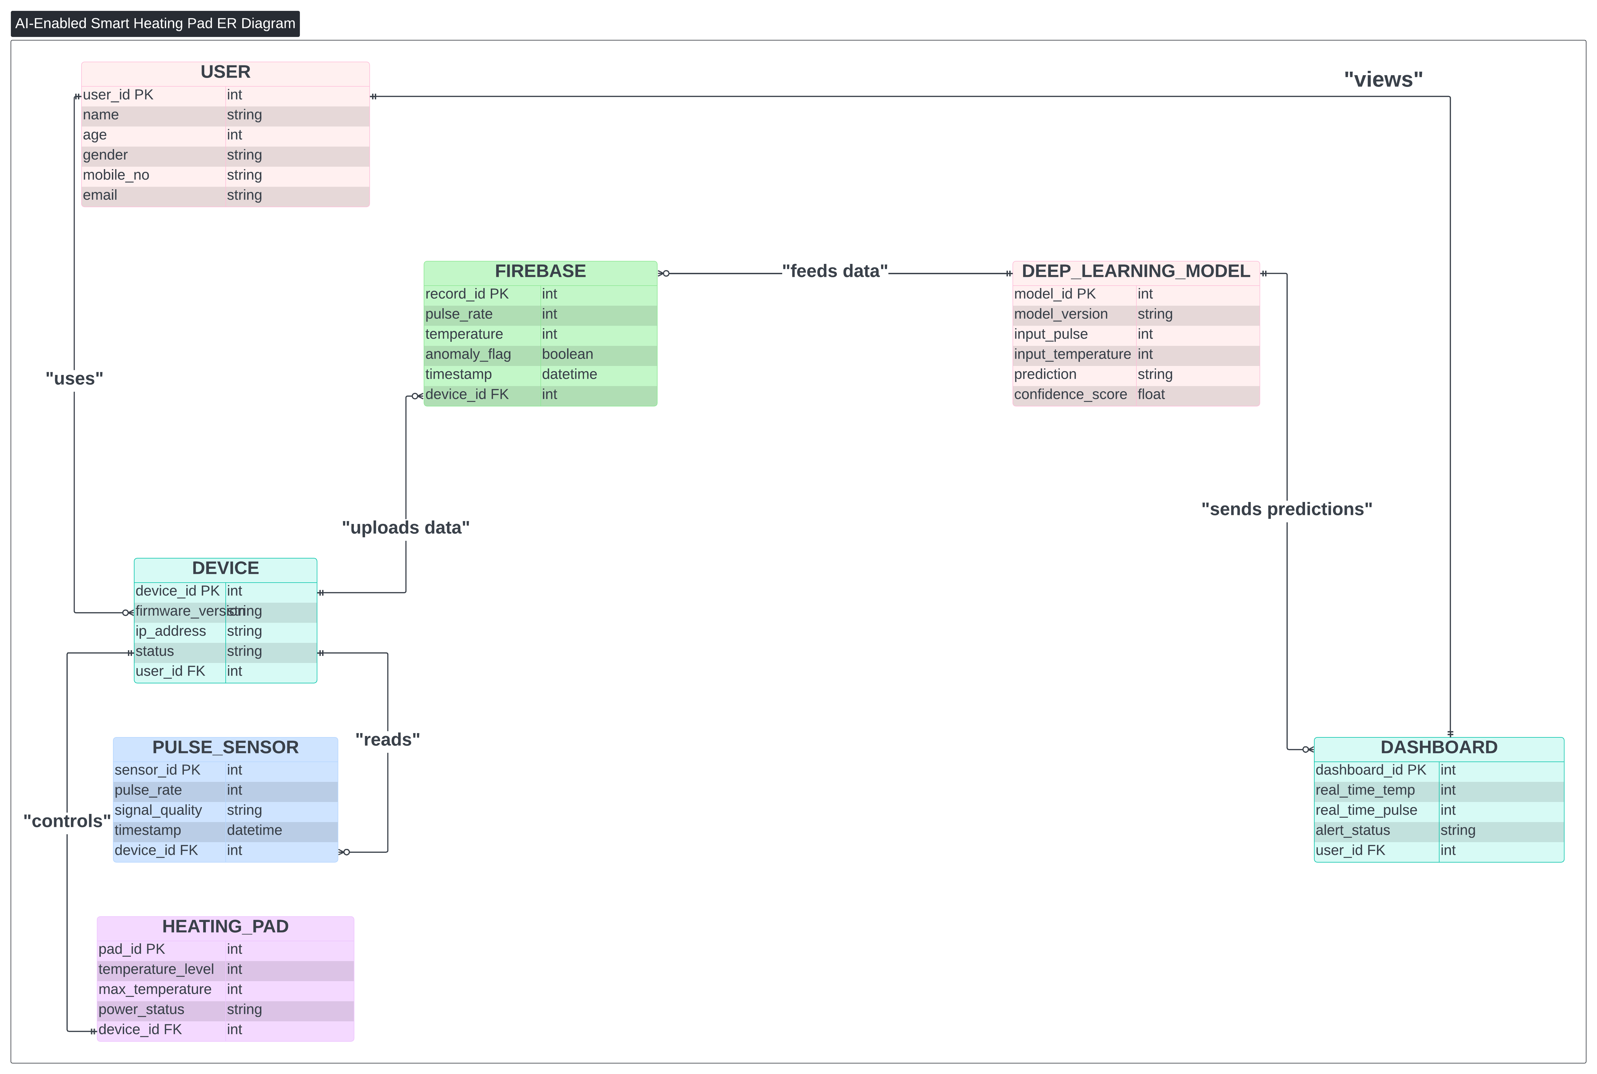
Fig1- Er Diagram

Data Flow Diagram

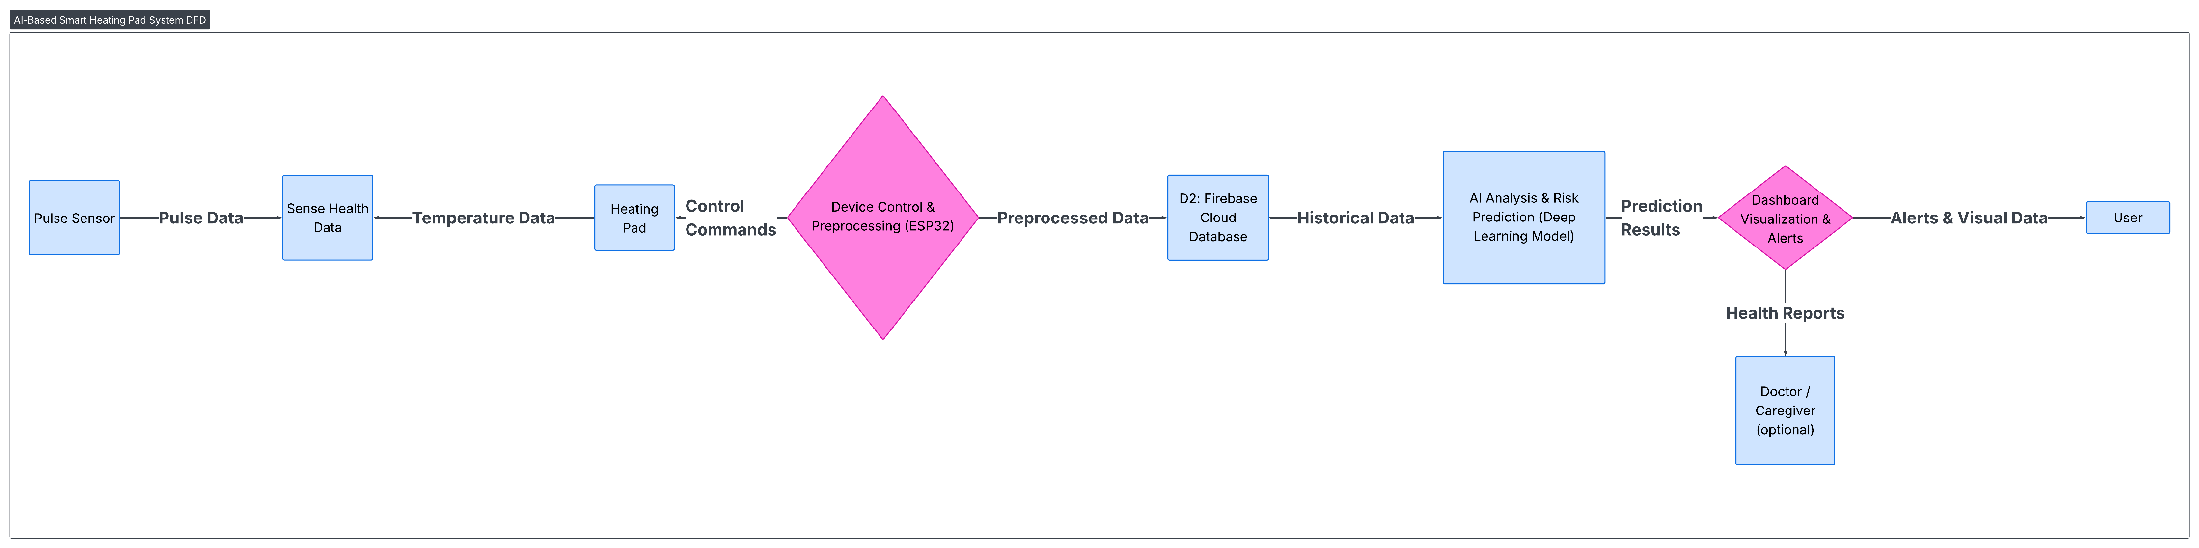
Fig2- Data flow Diagram

Use Case Diagram
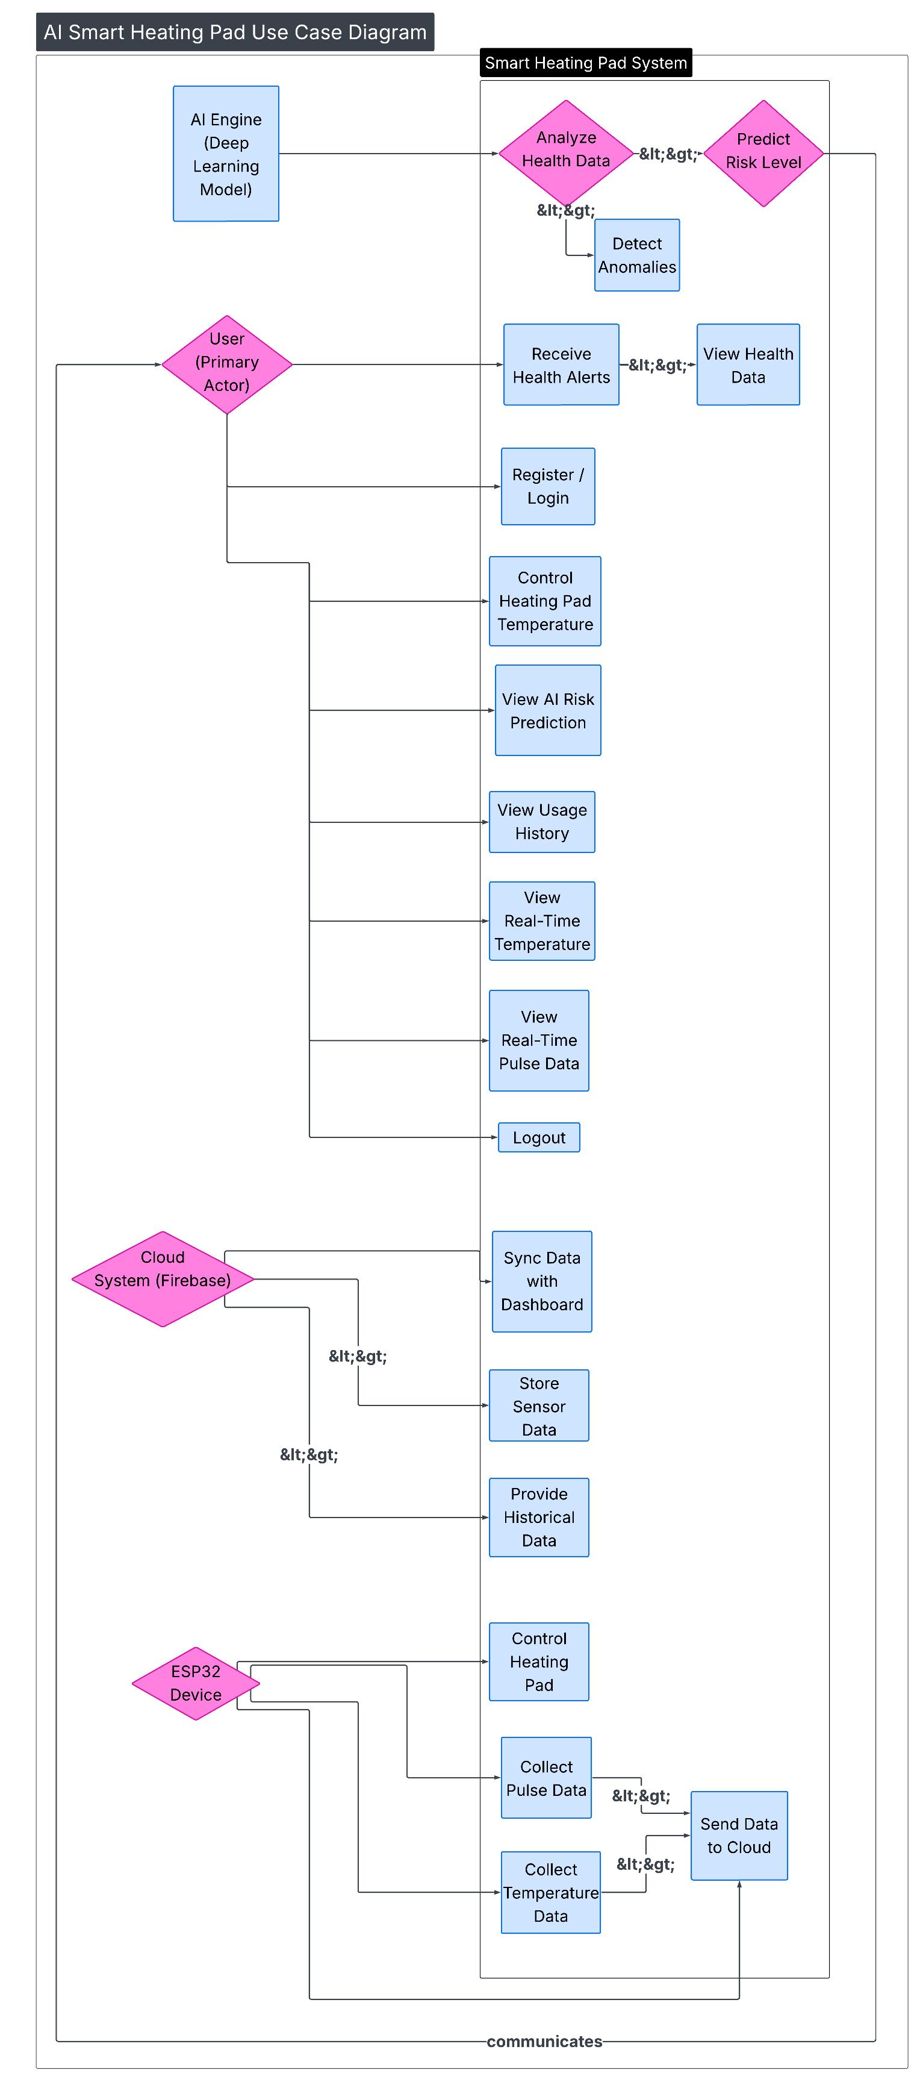
Fig3-Use Case Diagram

Software requirements
- Framework like Flask, FastAPI backend shall be used for data processing data.
- A database such as firebase or mongo db shall be used for data storage.
- Deep Learning frameworks- such as TensorFlow or PyTorch shall be used
- Web technologies (HTML, CSS, JavaScript) shall be applied for the dashboard.

Hardware requirements
- ESP32 microcontroller shall be used as a core controller.
- Temperature and pulse sensors shall be used for health monitoring.
- One type of thermal output program shall be employment of a heating pad or heating coil.
- A rechargeable battery shall be used for power supply.

Security
Security provides for protection of sensitive user and health data all through the system.

Protection
- The user passwords shall all be encrypted.
- Data transmission shall be secured with the help of encryption techniques.
- System activities shall be logged for auditing purpose.
- Inter-module communication not to allow talking to unauthorized components.
- Data integrity checks shall be done to prevent unauthorized modification.

